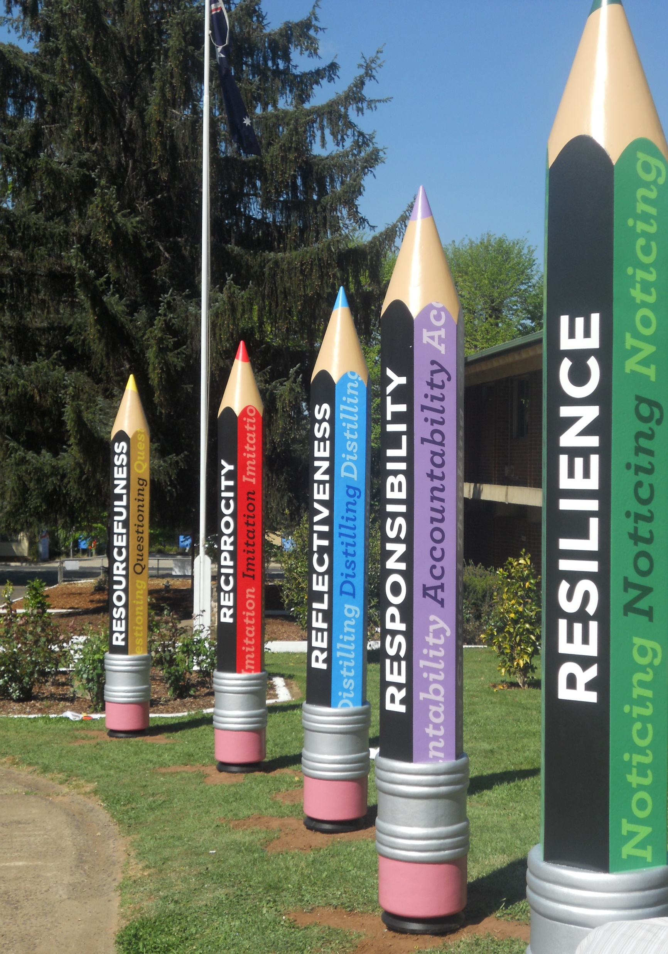
BATLOW TECHNOLOGY SCHOOL
FUTURE KINDERGARTEN TO YEAR 12
ENROLMENTS
We are in particular need of information for any students enrolling in 2020.
Could you please assist us by filling out this form and return it to Batlow Technology School office.

The children in your family who have not yet started school:

Child’s Name | Name and Address  of parents | Child’s date  of birth | Year of intended enrolment at BTS

FUTURE ENROLMENTS FOR OTHER STUDENTS
Children in families known to you who may not have access to this form:
Child’s Name | Name and Address  of parents | Child’s date  of birth | Year of intended enrolment at BTS

Thank you for your assistance

Michelle Wainwright
Principal

