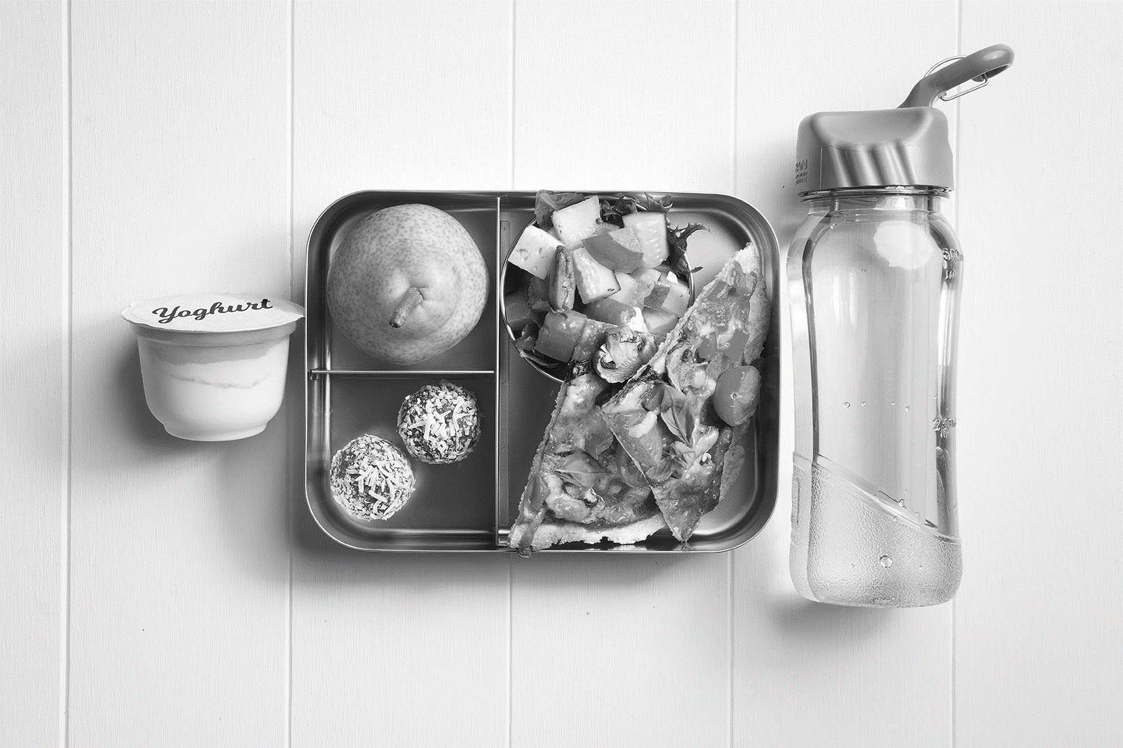
BATLOW BAKERY
PRICE LIST FOR
BATLOW TECHNOLOGY SCHOOL 2021
Mondays and Fridays only

HOT FOOD |  |  | SANDWICHES
Party pies | $1.00 |  | Ham | $3.20
Meat pies | $3.20 |  | Ham and cheese | $3.60
Sausage rolls | $3.00 |  | Ham and tomato | $3.60
Nuggets | $0.90 |  | Chicken | $3.20
Tomato or barbecue sauce | $0.30 |  | Chicken and cheese | $3.60
 |  |  | Chicken and tomato | $3.60
 |  |  | Vegemite | $2.80
 |  |  | Cheese | $2.80
 |  |  | Ham or chicken and salad  Lettuce, carrot, tomato, beetroot and cucumber | $4.80
 |  |  | add cheese for extra | $0.50
DRINKS |  |  | TOASTED SANDWICHES
Fruit boxes  Apple, apple and blackcurrant, orange and tropical | $1.60 |  | Ham and cheese  Chicken and cheese  Cheese | $4.00  $4.00  $2.50
Water 600 ml | $1.80 |  | Cheese and Tomato | $3.20
Flavoured milk 300 ml  Strawberry and chocolate | $2.70

