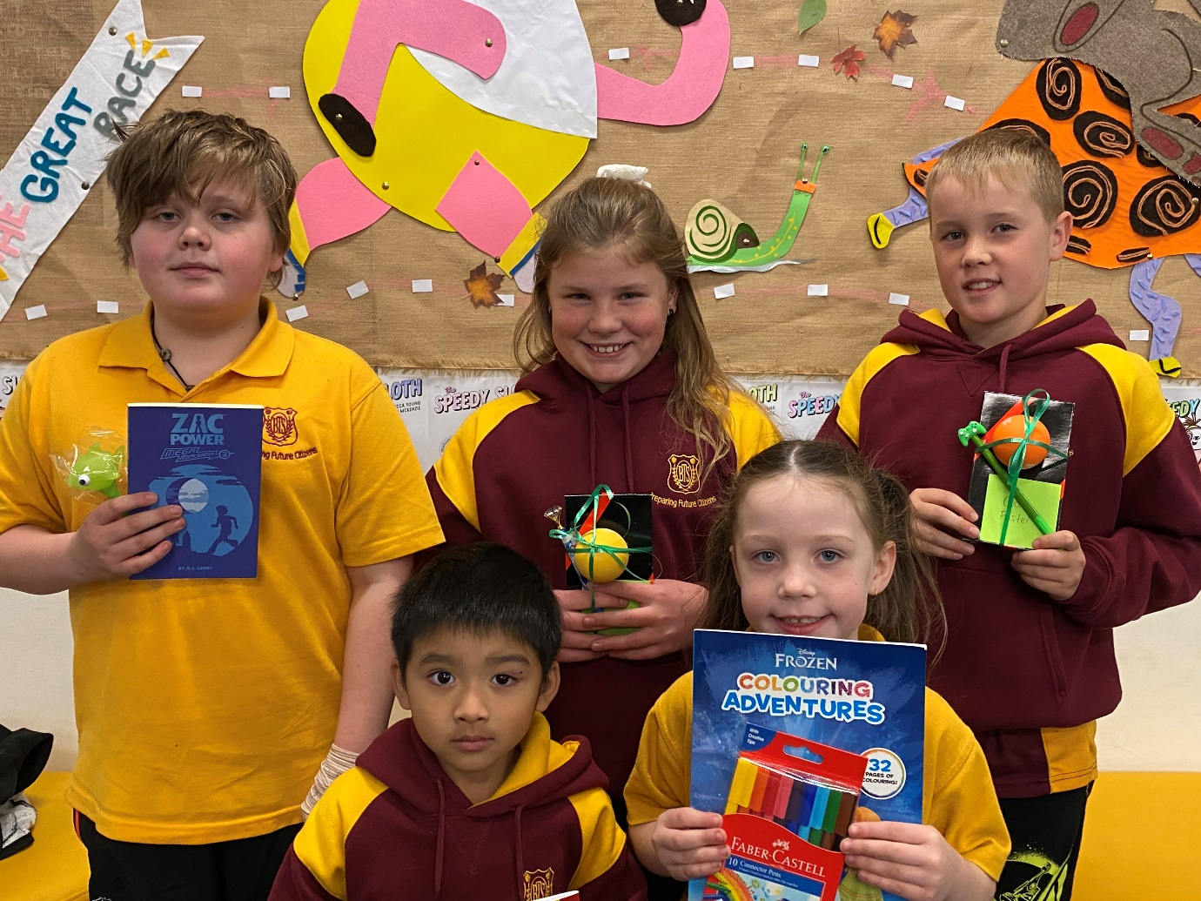
On Wednesday 24 May 2023 at 11.00 am, Primary students were among 2,199,785 participants who shared a live streamed reading from the
new Sydney Zoo at Eastern Creek
of The Speedy Sloth.

Pictured above are winners of
The Speedy Sloth colouring competition.

Congratulations to all Primary students who entered the colouring competition.
Batlow Technology School ‘Scoop’
National Simultaneous Storytime 2023

The Speedy Sloth written by Rebecca Young and illustrated by Heath McKenzie
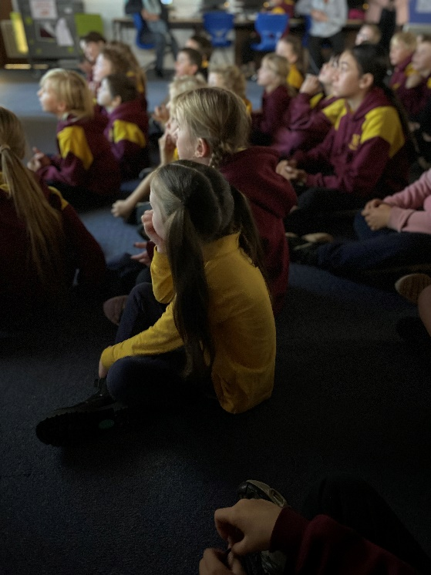
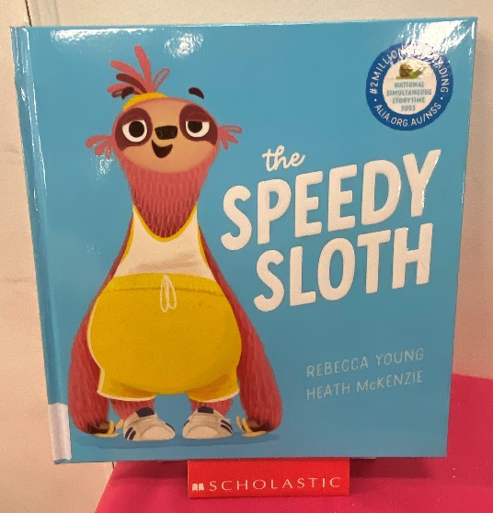
National Simultaneous Storytime 2023

The Speedy Sloth written by Rebecca Young and illustrated by Heath McKenzie.

It was finally time for the event of the year,
Spike couldn’t believe it—
THE GREAT RACE was here!
The other sloths said it couldn’t be done,
but Spike didn’t care, she was ready to run!
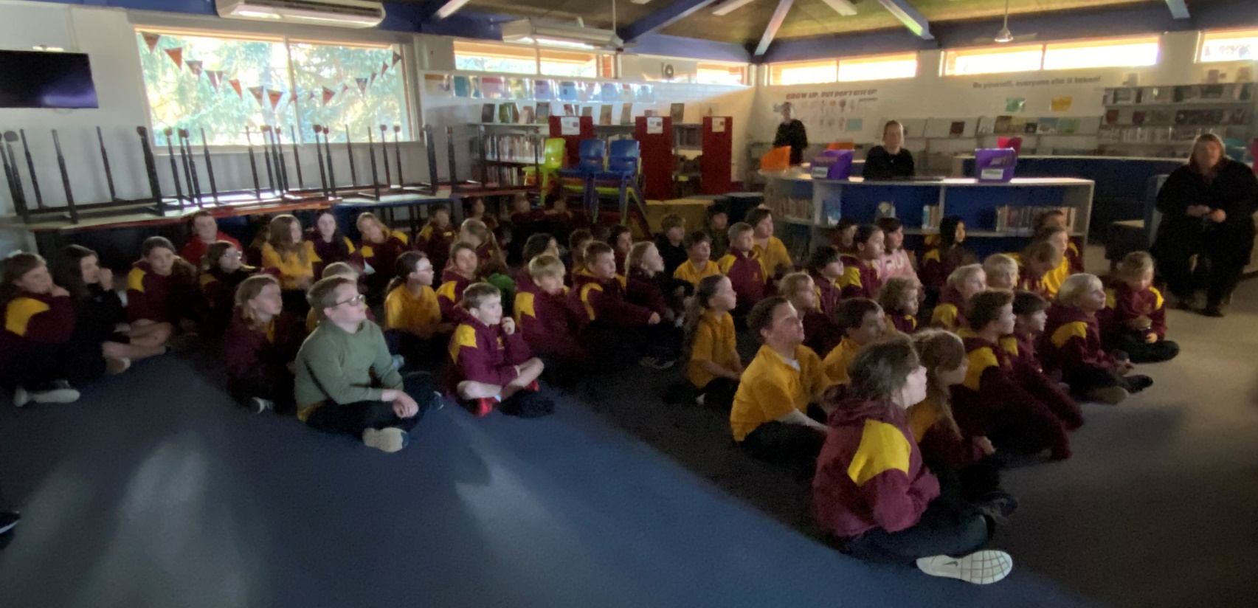
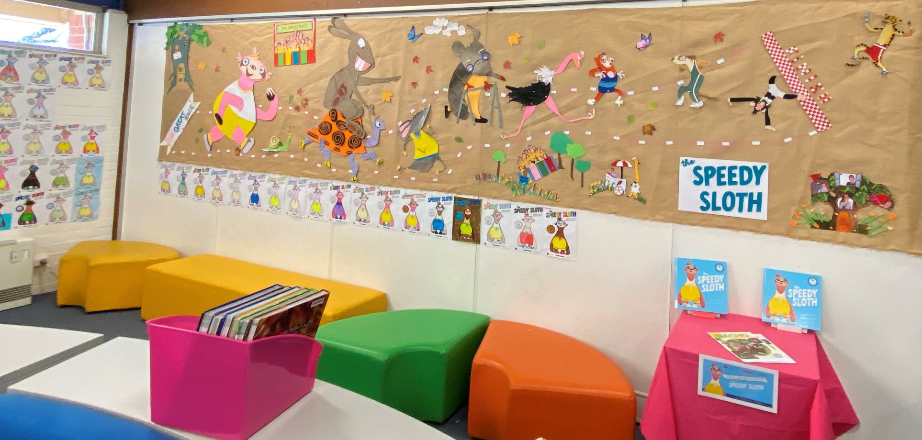
A beautiful display on our library wall by Ms Loren Curtis and Mrs Emily Smith.

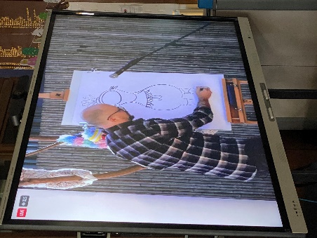
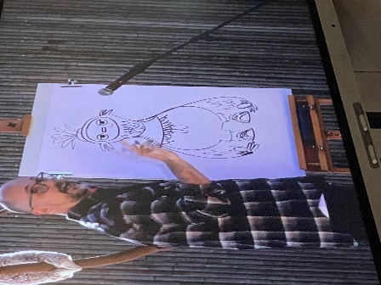
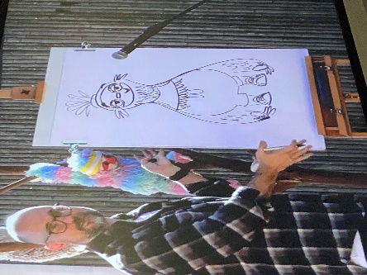
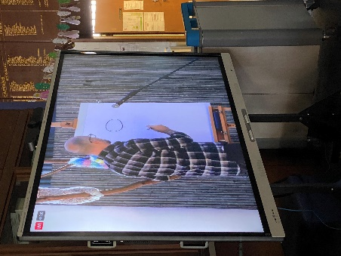
Step by step illustrations by Heath McKenzie on how to draw a sloth.

YEAR 5/6 NEWS
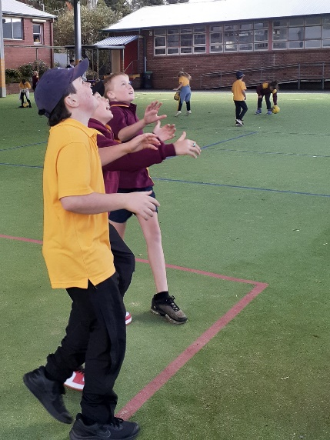
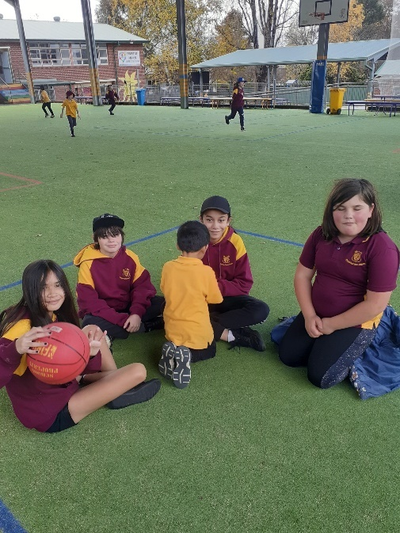
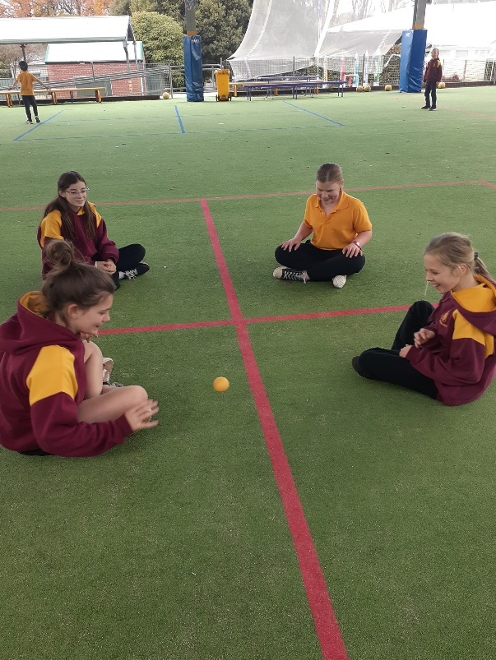
Year 5/6 students enjoying social interactions with their peers while playing basketball and handball.
Good sportsmanship and inclusive practices displayed by all students.

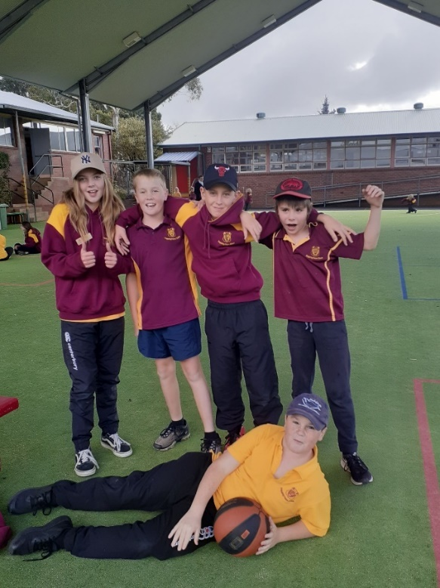
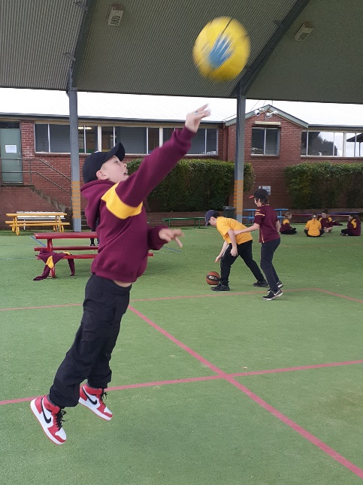

YEAR 3/4/5 NEWS
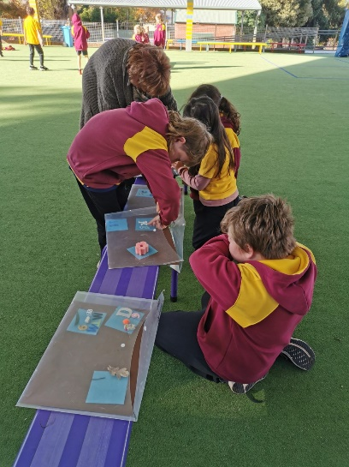
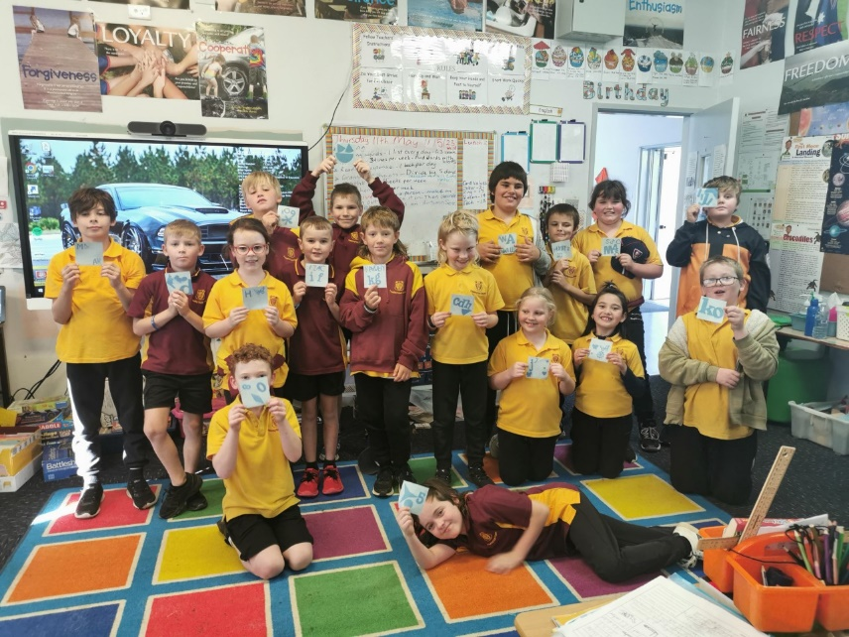
Year 3/4/5 have been learning about 'Space' in science. We are currently learning about the effects of the sun. We used light sensitive paper to see how the sun's light and heat effects things. Students chose items to place on their piece of paper and we noticed that after exposure to the sun, the paper changed colour around the items, leaving an impression of the shape of their items on the paper.

UNIFORM SALE
We have a limited amount of uniform available at Batlow Technology School.
The below sizes are available at a reduced price until sold out.

Primary Gold T-Shirts | Size 4 | $10.00
 | Size 6 | $10.00
 | Size 16Y | $10.00
Primary Sport Shirts | Size 4 | $10.00
 | Size 6 | $10.00
 | Size 16Y | $10.00
Secondary White Shirts | Size 10 | $10.00
 | Size 2XL | $10.00
Senior Secondary Maroon T-shirt | Size Small | $10.00
Black Track Pants | Size 16Y | $10.00
 | Size Medium | $10.00
 | Size Large | $10.00
Polar Fleece Jumpers | Size 4 | $10.00
 | Size 6 | $10.00
 | Size 10 | $10.00
 | Size 12 | $10.00
 | Size 14 | $10.00
 | Size 16 | $10.00
 | Size Small | $10.00
 | Size Medium | $10.00
 | Size Large | $10.00
 | Size X Large | $10.00
Maroon Jackets | Size 12 | $20.00
 | Size X Large | $20.00
School Buckets Hats | Size X Small | $5.00
 | Size Medium | $5.00
 | Size X Large | $5.00
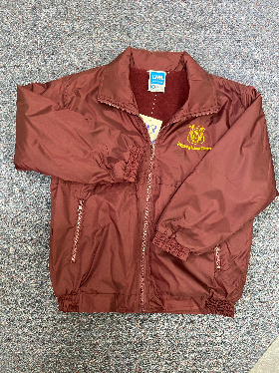
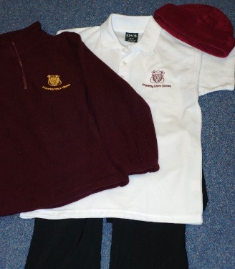
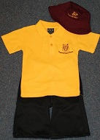
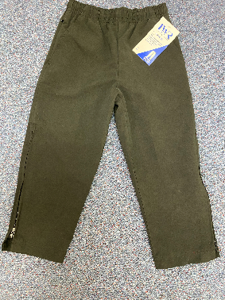
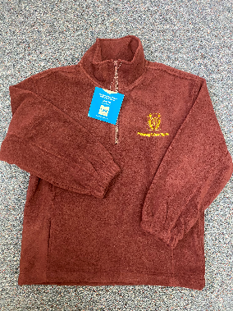

Please call into the school office for purchase.
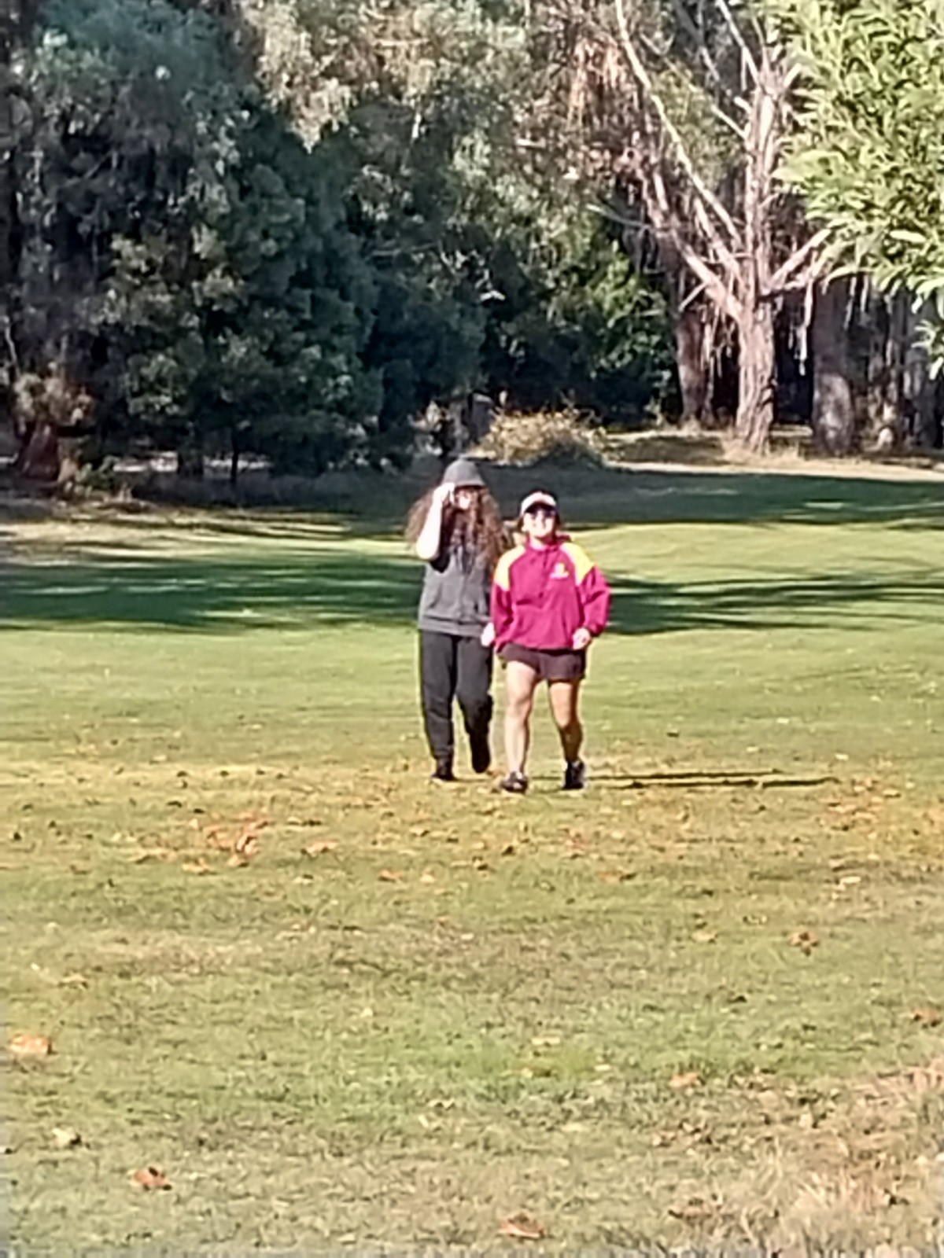
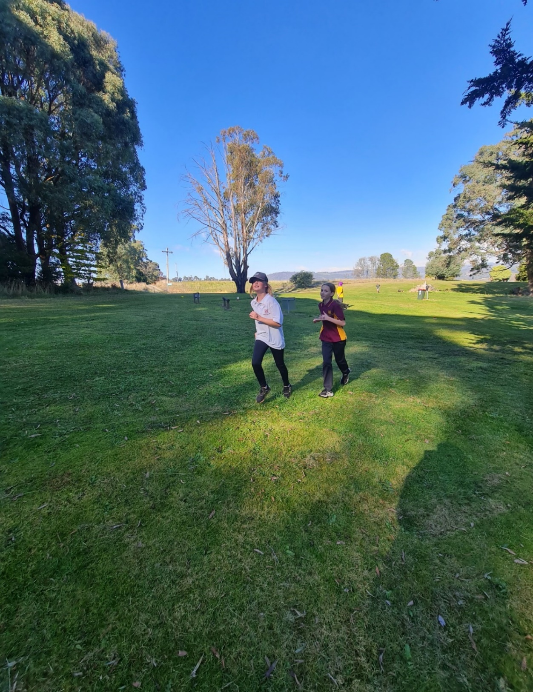
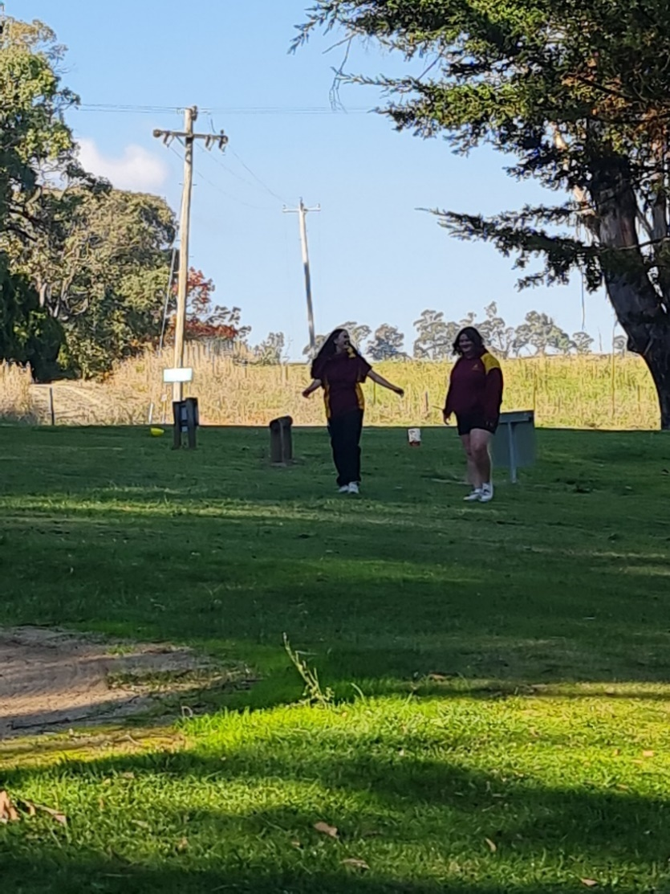
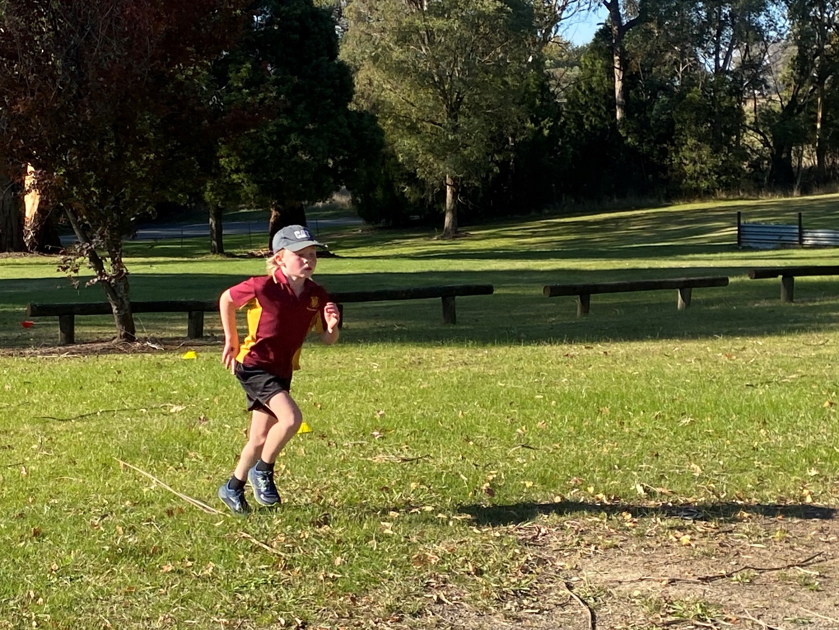
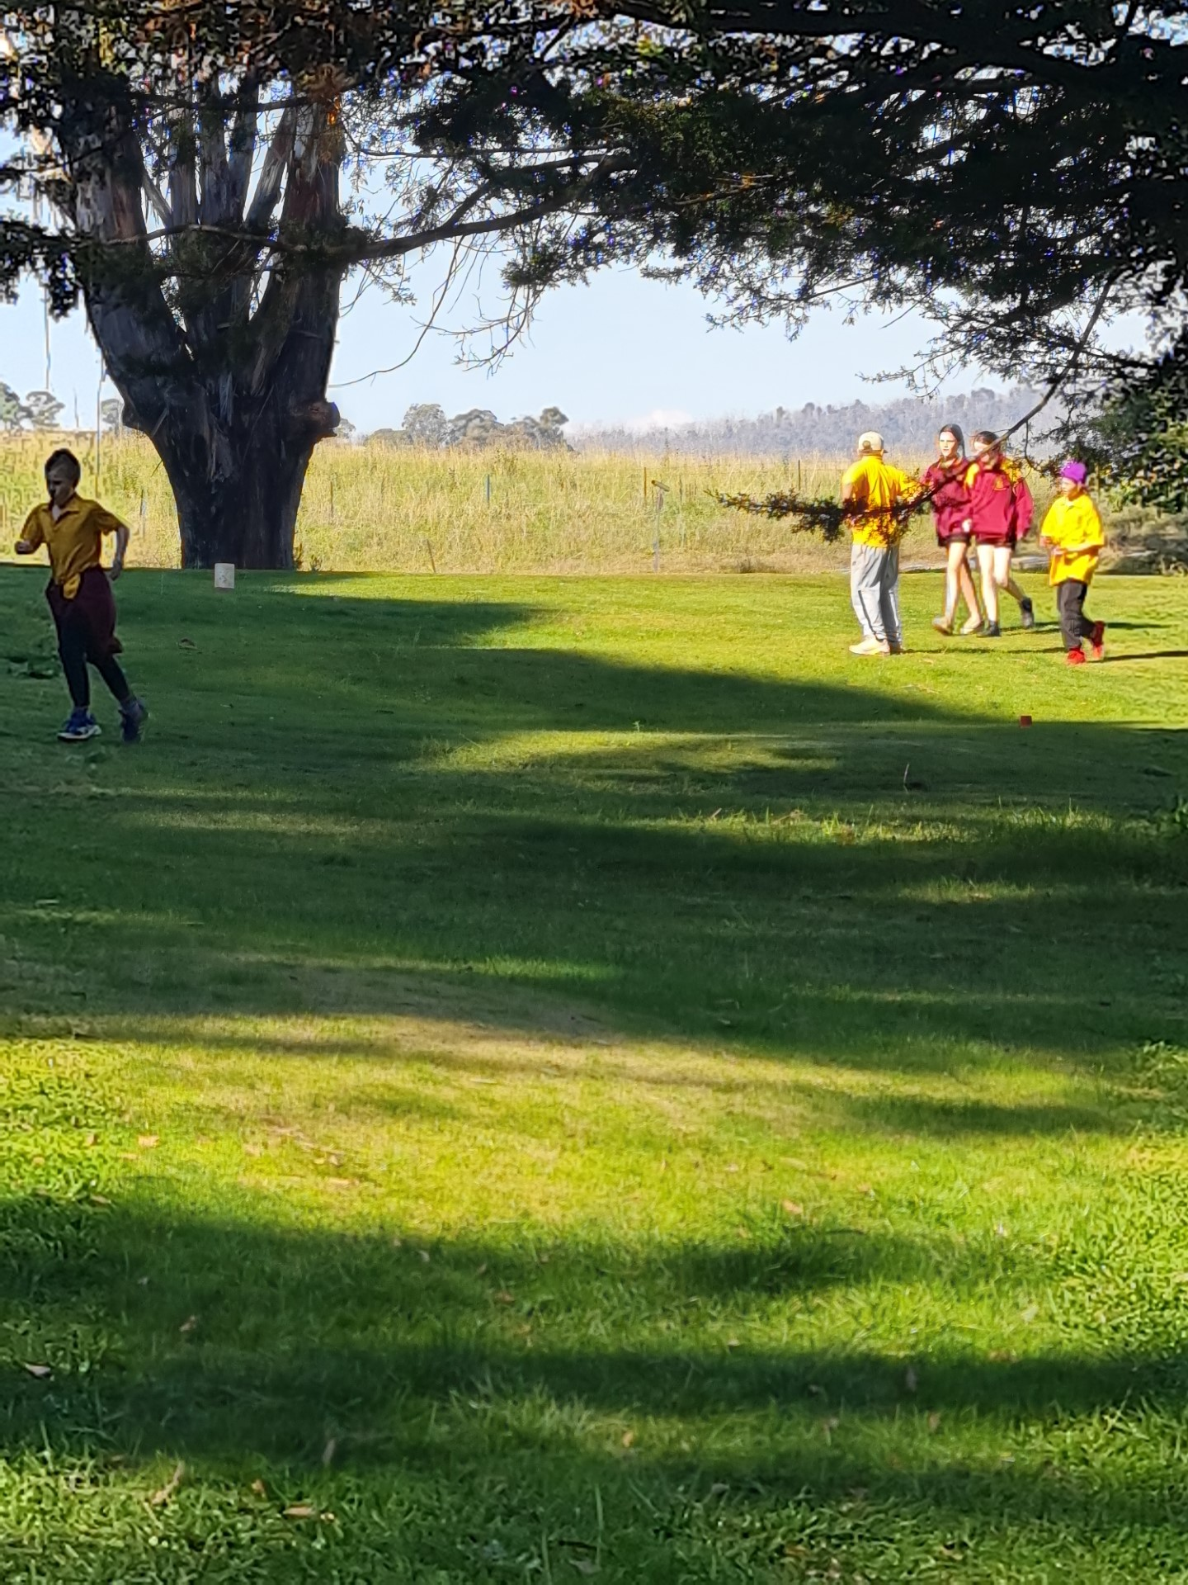
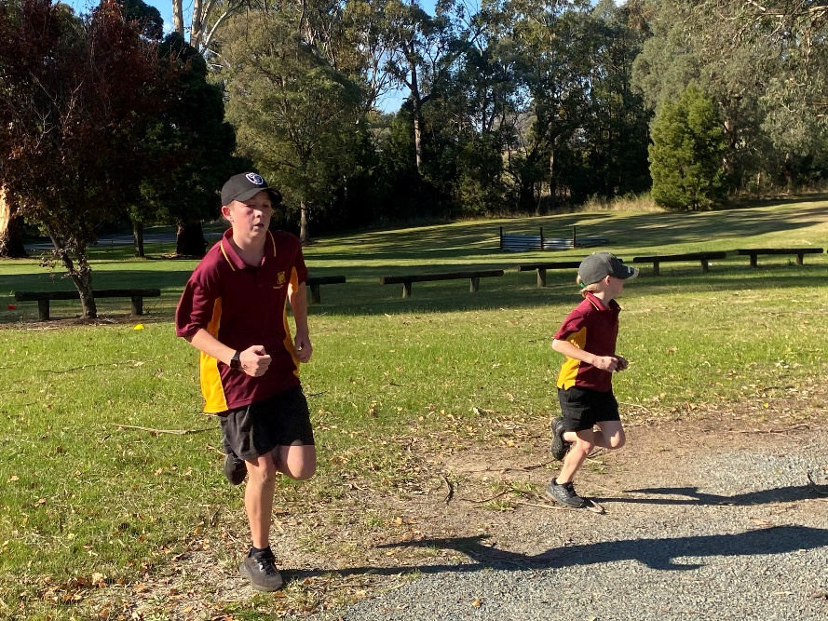
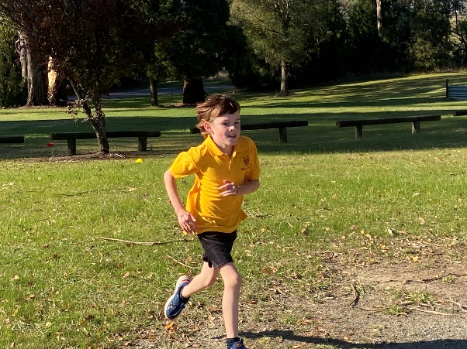
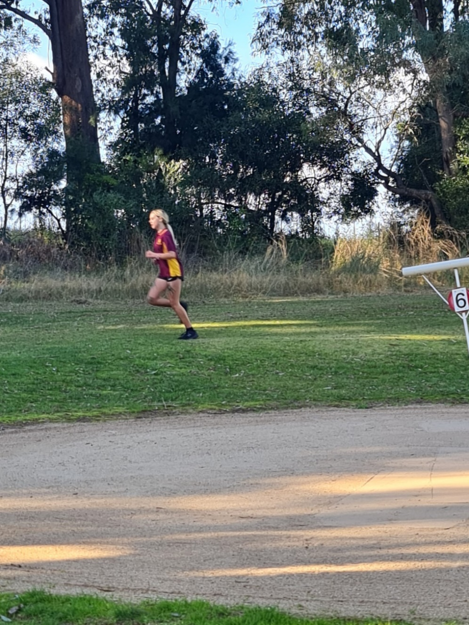
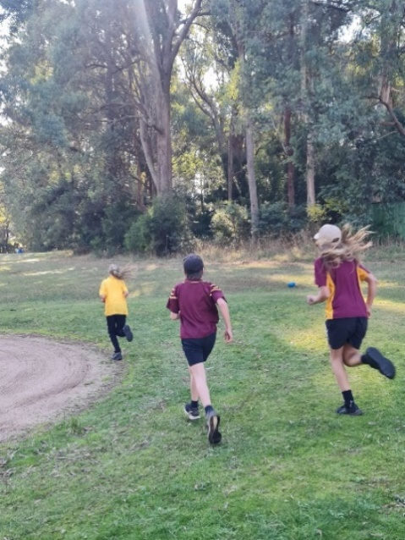
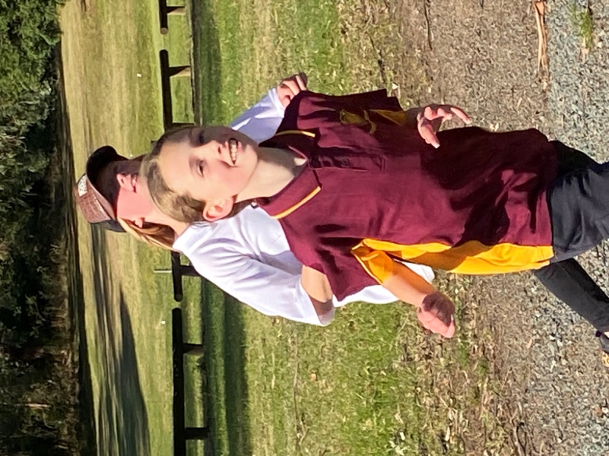
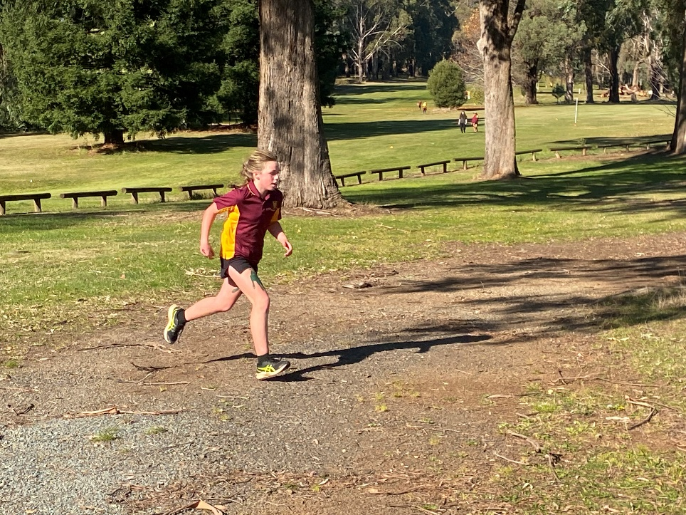
Whole School Annual Cross Country

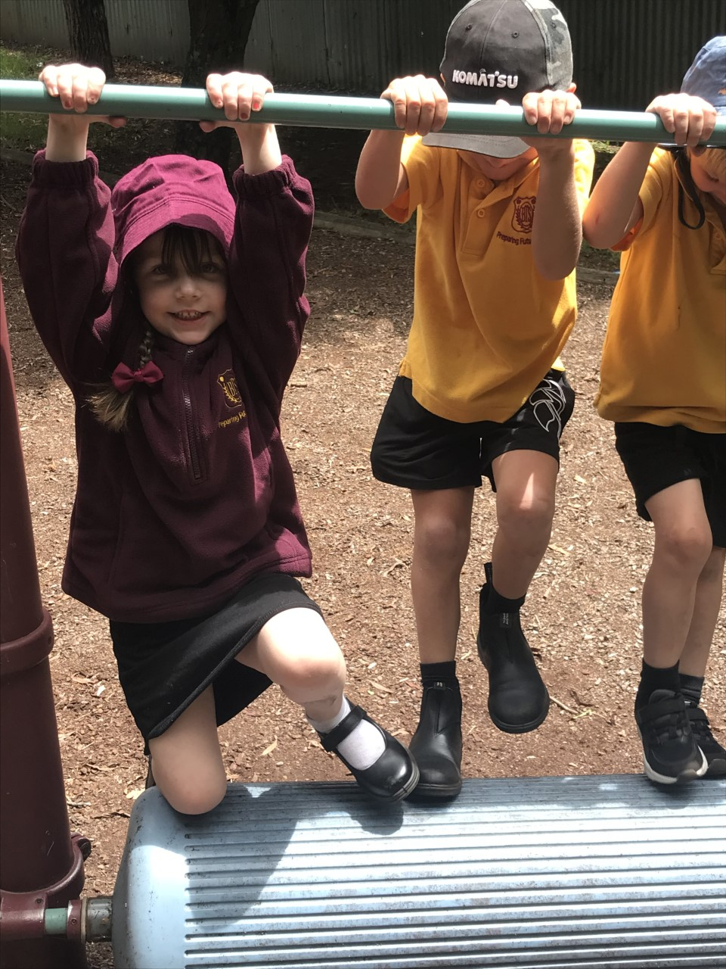
BATLOW TECHNOLOGY SCHOOL
FUTURE KINDERGARTEN TO YEAR 12
ENROLMENTS
We are in need of information for any students enroling in 2024.
Could you please assist us by filling out this form and return it to Batlow Technology School office.

The children in your family who have not yet started school:

Child’s Name | Name and Address  of parents | Child’s date  of birth | Year of intended enrolment at BTS

FUTURE ENROLMENTS FOR OTHER STUDENTS
Children in families known to you who may not have access to this form:
Child’s Name | Name and Address  of parents | Child’s date  of birth | Year of intended enrolment at BTS

Thank you for your assistance.

Michelle Wainwright
Principal


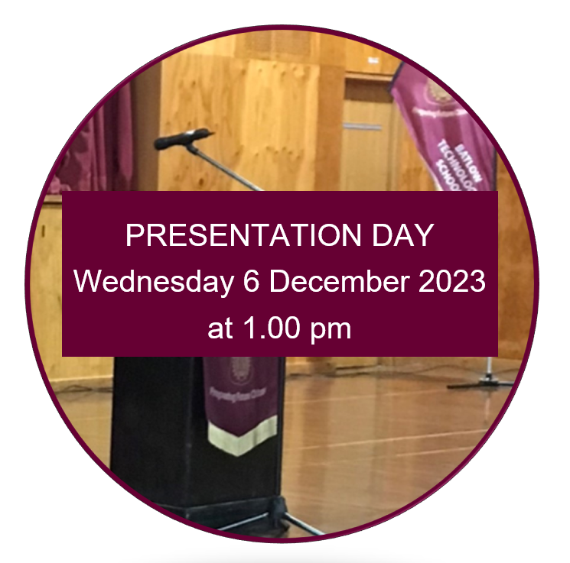

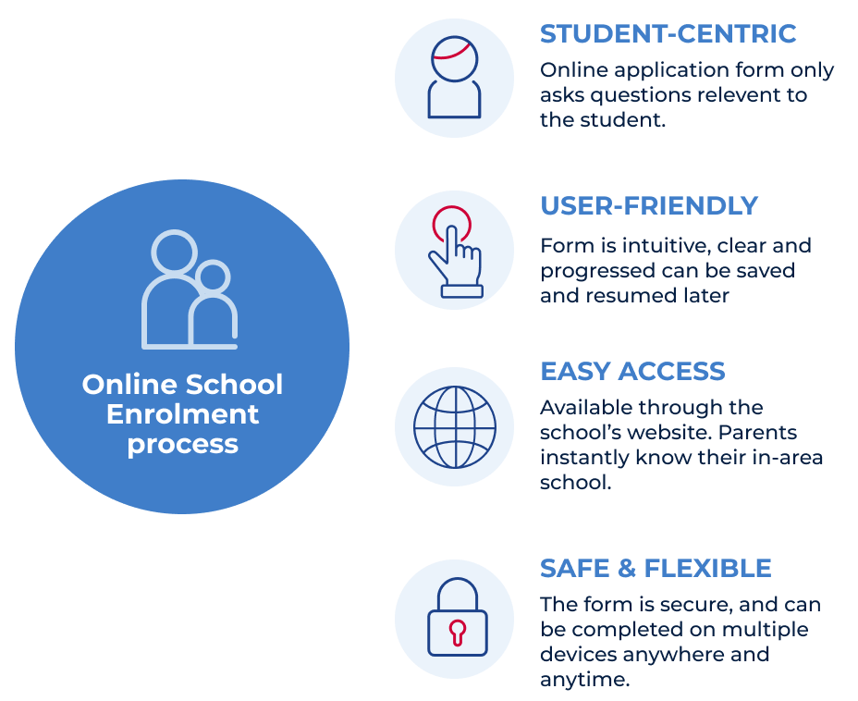
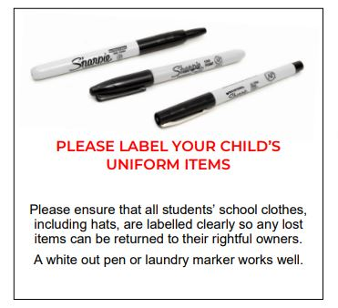
School Lunches

Coming into winter the months of the year it
is a good idea to pack more into your child’s lunchboxes
as we find the students have bigger appetites and are
eating more at recess and lunch.

Simple ideas are an extra piece of fruit, a healthy muffin,
muesli bar or a small wrap or extra half a sandwich.

KINDERGARTEN 2024
- All children must be in compulsory schooling by their sixth birthday.
- Children can start kindergarten at the beginning of the school year if they turn five on or before 31 July that year.
- Students should start school at the beginning of the school year.
- Contact your local school to discuss enrolment procedures on 6949 1208.

Application to Enrol in a NSW Government School or

Enrolment - Batlow Technology School (nsw.gov.au) School’s website page


What’s on at BTS
Breakfast Club Each morning, before school

BTS Lunches Mondays and Fridays

Open Parachute Wednesdays in Week B

Tennis Coaching Year K - Year 8 Thursday

Zone Athletics Carnival Monday 5 June 2023
(Secondary)
Temora Nixon Park Sporting Complex

King’s Birthday Monday 12 June 2023
Long Weekend

P&C Meeting Tuesday 13 June 2023

Riverina Cross Country Friday 16 June 2023
(Secondary)
Gundagai Showground

Last Day of Term 2 Friday 30 June 2023

Winter Holidays Monday 3 July 2023
Until Friday 14 July 2023

Mountain August 2023
Selwyn Snow Trip

